Hansen Wu

CS151 Homework 4 – Hard Copy

Model

The Model contains all data for the events. It takes care of all interactions with the data, and does all the processing and manipulation. It then tells view to update accordingly.

View

View contains all necessary elements to display the application GUI, and only contains and processes data that is essential to displaying SimpleCalendar.

Controller

The user interactions are all handled by Controller. On start, it creates Model and View to launch the application. The listeners for buttons are contained inside, and when user sends input through buttons, controller tells Model to do an action.

Screenshots:

Screen 1: After starting the application (initial screen)

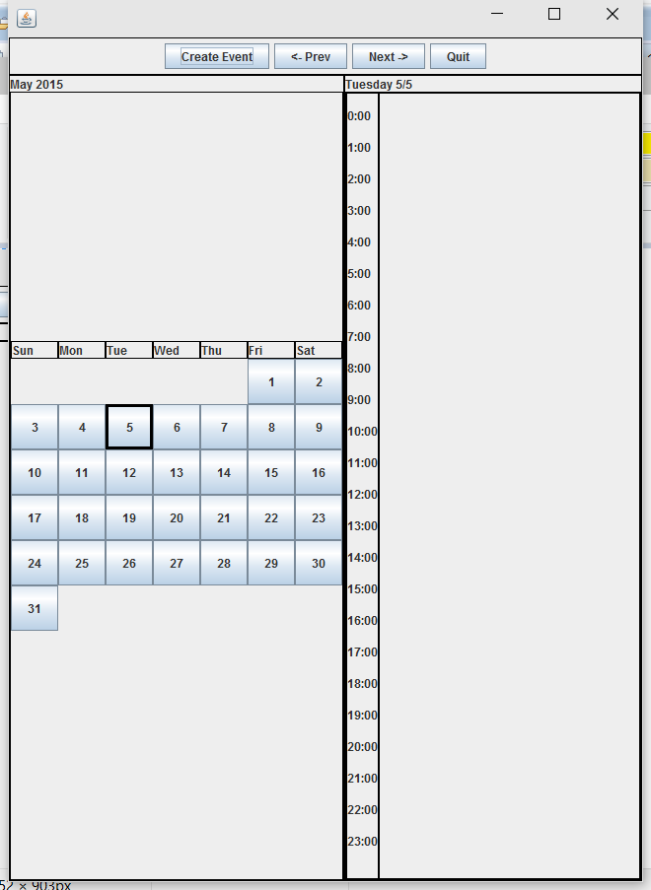

Screen 2: After clicking on the previous button on Screen 1

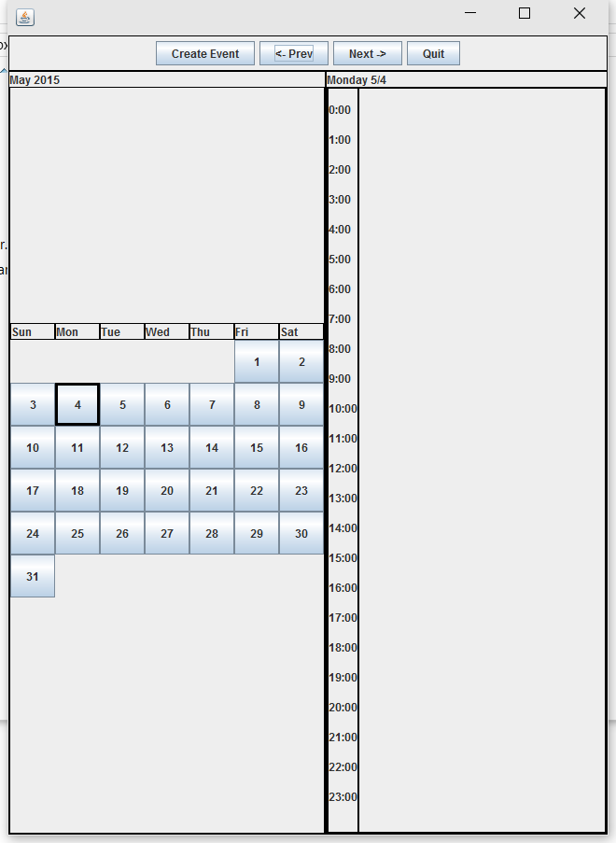

Screen 3: After clicking on the next button 20 times from Screen 2

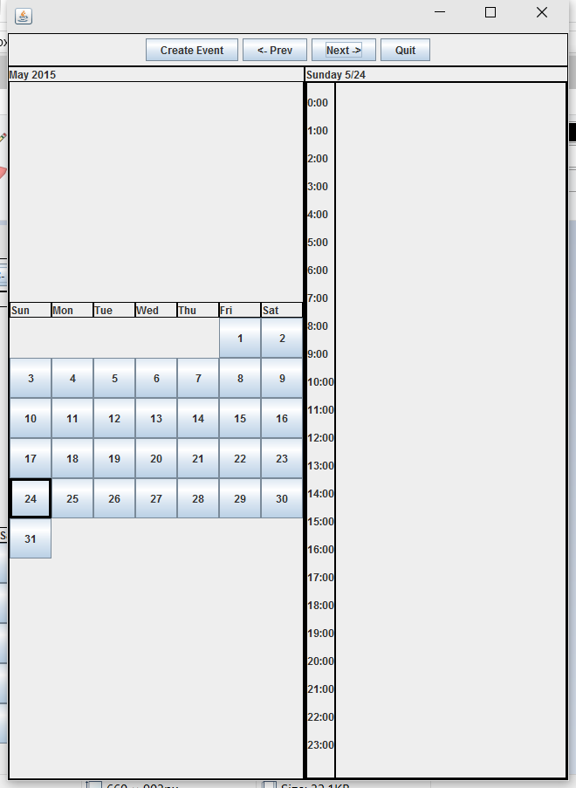

Screen 4: After clicking on a particular day on Screen 3 and creating an event on that day.

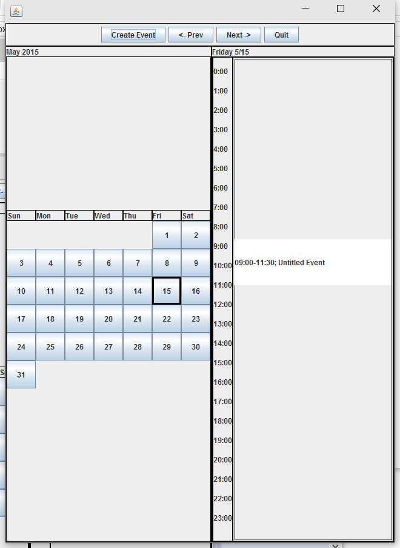

Screen 5: After clicking on the same day you choose in the previous step and creating an event with a time conflict.

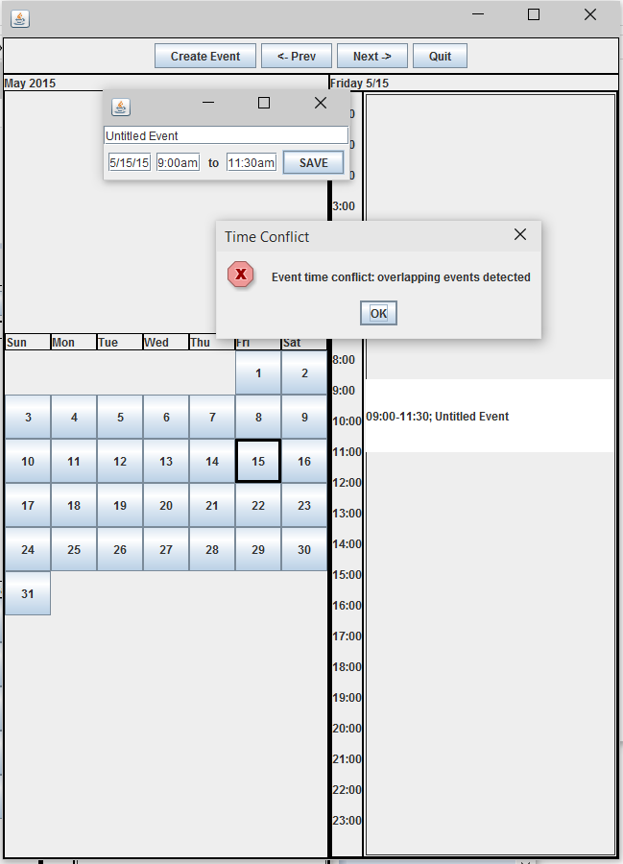

Screen 6: After entering an event on the same day you choose in the previous step and creating an event without a time conflict.

